In this section we will discuss how to make a 3D zigzag Game.
(Video is old)
So first create a new project
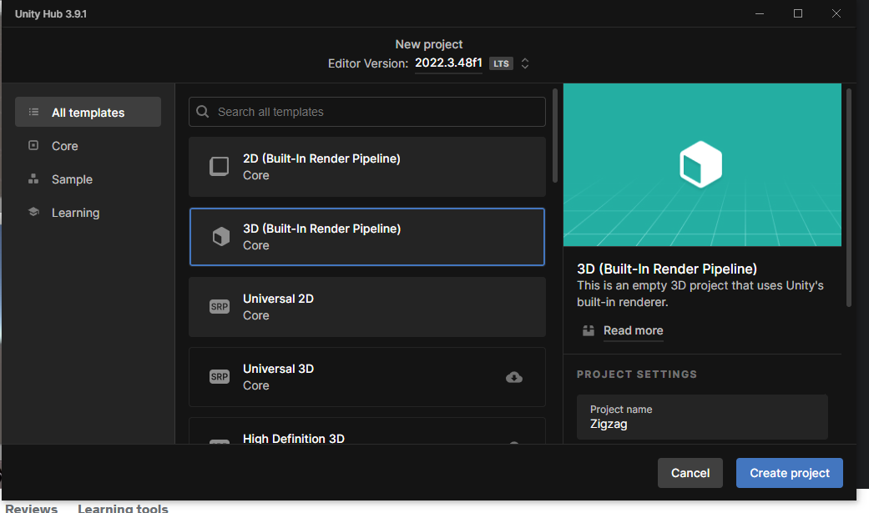
Note:-
When you go to junction between two panels then you can resize them by dragging to toggle its height, width.
In the game panel you can set your own custom aspect ratio by going to the menu of aspect ratio aand then click on the + button present in the submenu of the aspect ratio.
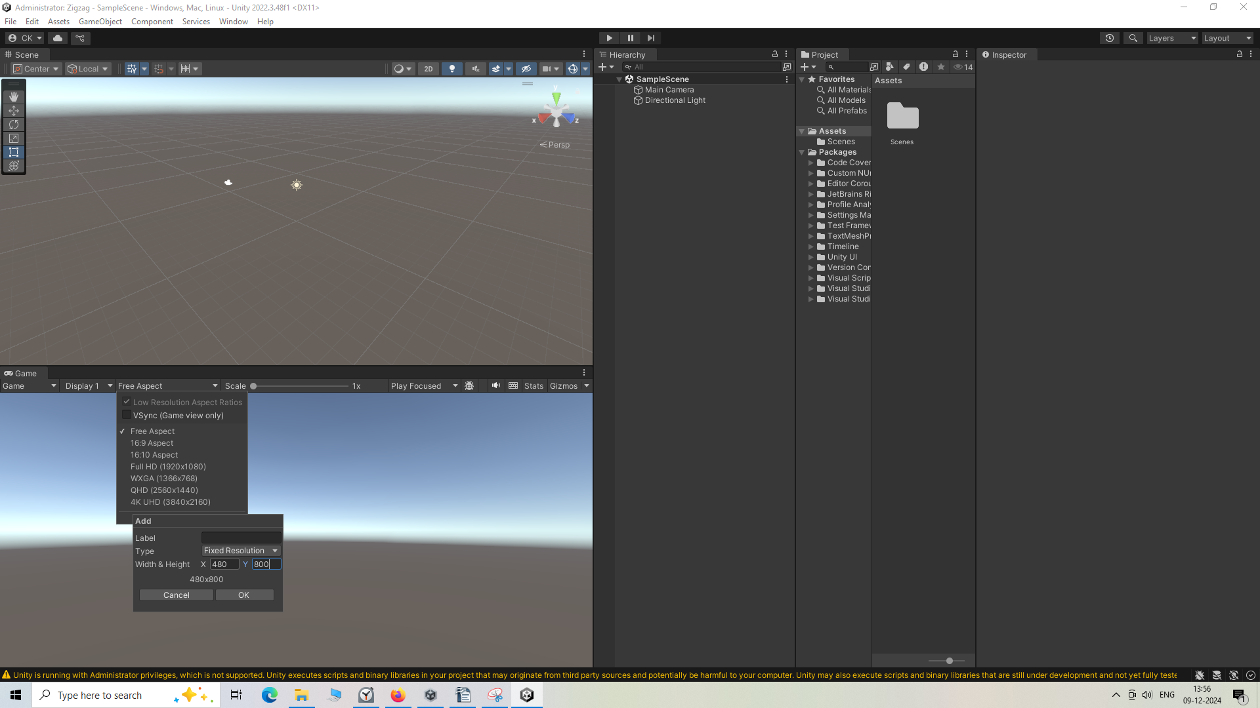
Now the game panel screen will look like a phone screen. Now it will look like Phone screen which make it easy for us see like it will look in phone actually when we build it.
Now a create a folder named scene (Nowadays scene folder come inside the assets folder by default in newwer version of unity) .in scene we keep all the scene in this scene folder.
Now we will create a new folder inside assets folder called script where all the scripts of the game reside.
We again create a folder called material where we will keep our game Materials.
We again create folder called our PhysicsMaterial folder (I don't know) where we keep our physics folder.
In older Unity we have a default scene but not saved in folder structure so to save it go to file>Save Scene to create file corresponding our scene in the unity
but now in newer version it happens by default so you can wither create new scene or rename the default scene if you want Now you can go to File > New Scenes and then save the scene folder if you want for the organisation
__________________________________________
Note:-
If you put more than one scene in your heirarchy then they will overlap each other.

Lets create a cube
Make sure the position of object is 0 in all axis if not then reset '
Now scale the x axis as 10 and z axis as 10
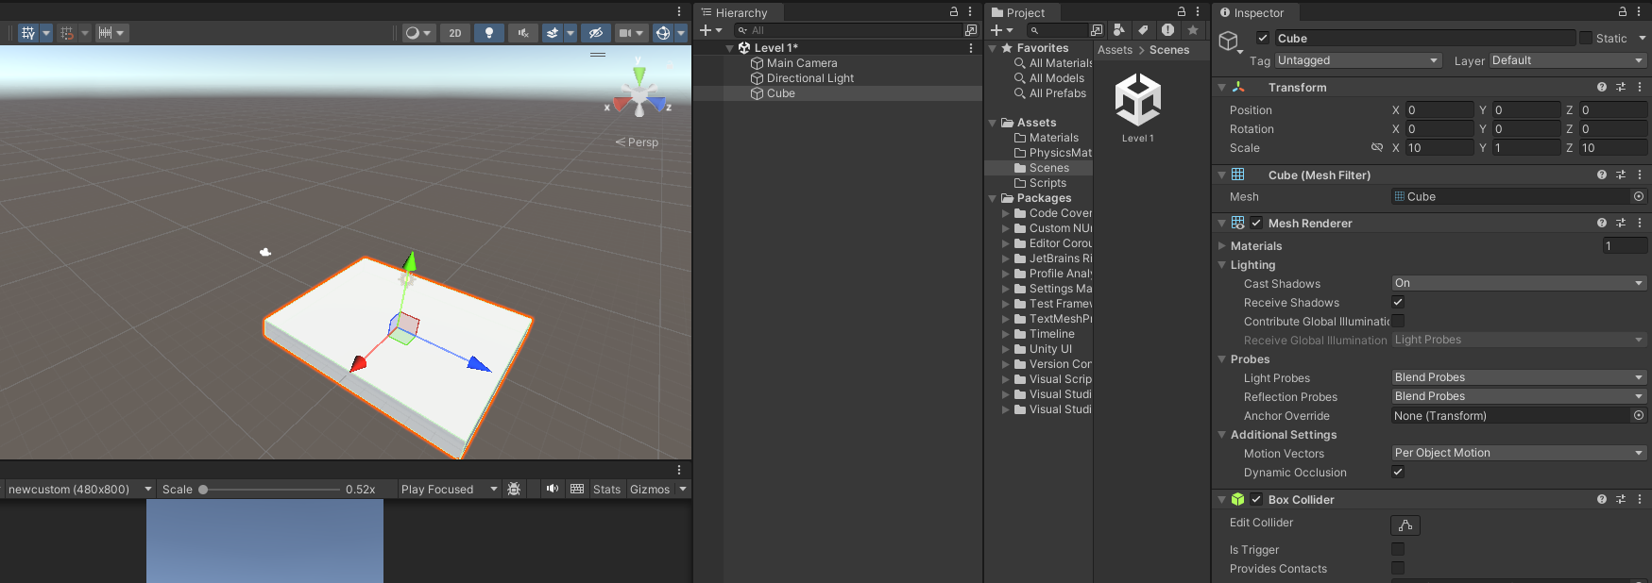
so that it acts as a first platform
Don't worry about the game panel focus on the scene panel as we will work on it.
We will need to create a ball which will actually the player will control
So create a sphere in the same way you created cube
Now we are going to create two materials one is for cube and another is for
To focus on a selected object (means the scene panel will show the view from the selected IOA)
in scene panel. press f.So make a material inside the material folder and name it as Blue
We will use this "Blue" material on platform.
Now go to albedo sub option in Main Maps
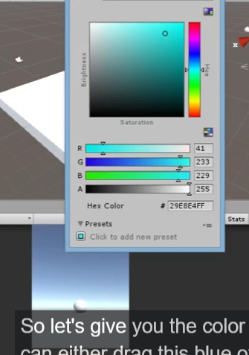
we give the color as shown above
To apply this you can drag the material to the IOA in the scene panel and Heirarchy
To duplicate something first select the object or anything you want to duplicate and then press on ctrl + D
you can rename something by selecting the thing you want to rename and then press F2
Rename the cube as PlatformStart
Now rename the sphere as Ball
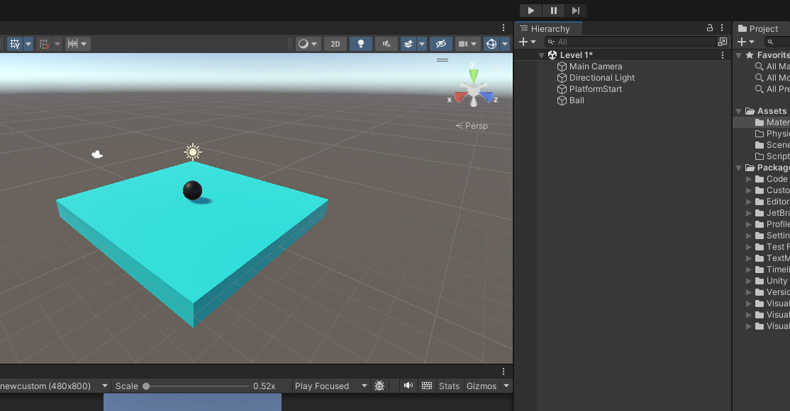
If you see the Ball IOA then it has a Sphere collidor attached to it as marked below.
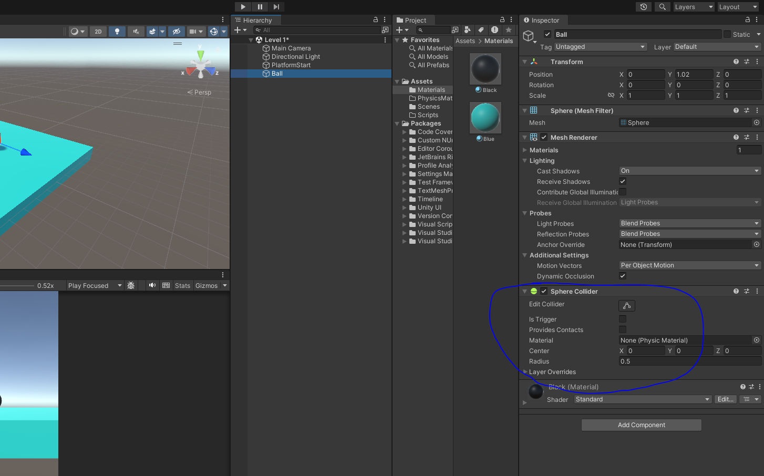
So every sphere has a sphere collidor.
It will help to detect the collision of our ball to other object
Similarly for PlatformStart we have Box collidor
Now we will add Component to the ball that is RigidBody component.
Now ball will be able to interact with the physics engine of Unity
o now if the game is running and i pull it up in the sky move tool then it will drop down on the ground due to gravity.
We don't want to include gravity
so go to inspector panel of the ball
and then uncheck the Use Gravity as shown below and also make the angular drag 0 so that no rotation act externally(who knows) as shown below
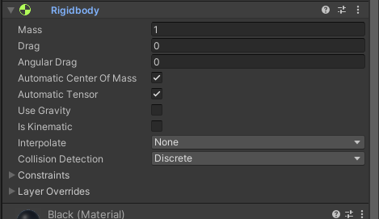
If we want that the sphere should not move in upward direction so we now expand the Constraints and the check the chekbox freezing the movement or position along y axis.
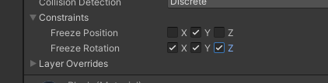
We will now freeze the rotation along x, y and z axis. As shown above.
I think when you save unity you save the scene(who knows)

